Cub Scout Pack 1180 Spring Family Campout

Location: Stephen F. Austin State Park, San Felipe, TX
Dates: Friday April 24th – Sunday April 26th
Park Website - https://tpwd.texas.gov/state-parks/stephen-f-austin

1. Vital Information & Emergency Contacts
- Park Address: 1201 Park Rd 38, San Felipe, TX 77473
- Park Office: (979) 885-3613
- Closest Hospital (24/7 ER):
  - Memorial Hermann Katy Hospital (approx. 20 mins)
  - 23900 Katy Fwy, Katy, TX 77494 | Phone: (281) 644-7000
- Pack Emergency Contacts
  - Emergency Camping POC 1: George Washington (Camping Lead)
  - Emergency Camping POC 2: Abe Lincoln (Cub Master)
  - Emergency Camping POC 3: Tom Jefferson (Pack Committee Chair)

- Health & Safety Contact: John Adams (number) (Will hold all Medical A/B Forms)
  - If you have medical training please let me know so we can mark tents appropriately.
- Other Information
  - There will be NO electrical hook ups at the campsites, so please plan according.
  - Unless you have an annual pass or group pass, each individual over 13 will be charged $5 per day. Families are responsible for payment of fees as the pack only covers campsite reservations.
  - Remember that there is no alcohol permitted on BSA events
- Weather Forecast
  - Friday morning rain is expected in San Felipe, TX but the rest of the weekend should be clear
  - Do not forget to pack accordingly; Saturday will be warm so remember to stay cool and hydrated.
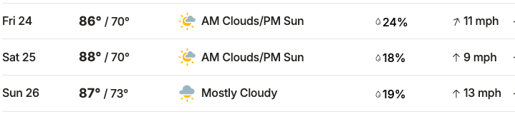

2. Weekend Schedule
- Friday
  - 2:00 PM: Arrival & Setup (anytime after 2pm)
  - (Den) Dinner individual / Den Meals
  - 10:00 PM: Quiet Hours
- Saturday
  - (Den) Breakfast Individual / Den Meals
  - 9:00 AM – 12:00 PM: Den Activities
  - 10:30 AM: (1-2mi Optional) Hike with a Ranger - Meet at the Amphitheater
  - 12:00 PM – 1:30 PM: Lunch (Den Meals)
  - 1:30 PM – 3:30 PM: Afternoon Activities / Skit Practice
  - 2:00 PM: Pack Bucket Brigade (site 67)
  - 3:30 PM: Webos Meet at Campfire (site 67) for Setup
  - 4:00 PM: Pack Campfire & Skits -site 67 (Every Den presents 1 skit or song)
  - ~5:30 PM: Dinner (Den Meals)
  - 10:00 PM: Quiet Hours

- Sunday
  - (Den) Breakfast Individual / Den Meals
  - (Den) Strike Camp / Leave No Trace & Sweep Area
  - Check-out & Departure (check out is 12pm)

3. Leader Meal Planning Instructions
Meals will be managed at the Den Level for this trip.
- Den Leaders: Please coordinate and communicate within your Den (if you have not already done sone)
- Requirements: Ensure you have a plan for Friday dinner (if not eating before arrival), Saturday Bfst/Lnch/Dnr, and Sunday Bfst.
- Safety: Sites will have access to water Den should bring its own water jugs and a dedicated washing station (3-basin method).

4. Saturday Activity Suggestions (Stephen F. Austin SP)
Since this park features bottomland forests and Brazos River views, here are some Scout-friendly ideas:
- Nature Scavenger Hunt: Look for the Pileated Woodpeckers or White-tailed deer common in the park.
- The "Six Essentials" Hike: Use the Iron Bridge Trail or Brazos River Nature Trail for a guided hike on hiking safety. (see trail map link)
- Historical Exploration: Visit the San Felipe de Austin State Historic Site (adjacent to the park) to learn about the "Father of Texas." (the cost is not included with park admission) https://thc.texas.gov/historic-sites/san-felipe-de-austin
  - There is a cost for visiting but I’ve included a discount voucher in the attachments.
- Visit the Nature Center and check out our displays, participate in games or activities, and ask questions.
  - https://tpwd.texas.gov/calendar/stephen-f-austin/nature-center-hours-4/2026-04-25
- Hike with a Ranger join TxPD for a peaceful walk through the unique ecosystem of the bottomland and forest.
  - https://tpwd.texas.gov/calendar/stephen-f-austin/hike/hike-with-a-ranger/2026-04-25
- Geo Caching - the modern day treasure hunt
  - https://tpwd.texas.gov/state-parks/parks/things-to-do/geocaching
- Become a Junior Ranger!
- Borrow an Explorer Pack loaded with tools for exploring the park.
- Pick up a free Junior Ranger Activity Journal at the park. Complete tasks to earn a badge.

5. What to Bring?

See the chart below to help plan everything you want to bring for this weekend!
The burn ban has been lifted, there should be no rain (but rain gear is always recommended), and we will likely have warm days and cool evenings.

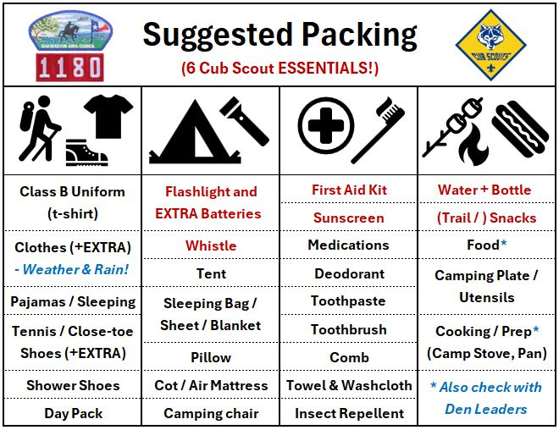

6. Campsites, Locations and First Aid

The families have been assigned the following campsites. We should hopefully have enough parking if each family is driving a single vehicle but if this is a problem please let me know. We should have markings on tents for medical assistance.

Rank | Family | Site
Lion | Washington | 51
Lion | Hayes | 51
Lion | Jefferson | 52
Lion | Adams | 52
Tiger | Roosevelt | 53
Tiger | Clinton | 53
Tiger | Lincoln | 54
Tiger | Bush | 54
Tiger | Hoover | 55
Tiger | Garfield | 55
Tiger | Cleveland | 56
Tiger | Kennedy | 56
Wolf | Trump | 59
Wolf | Obama | 59
Wolf | Ford | 60
Wolf | Biden | 60
Wolf | Reagan | 61
Wolf | Carter | 61
Wolf | Nixon | 62
Wolf | Monroe | 62
Bear | Truman | 63
Bear | Wilson | 63
Bear | Coolidge | 64
Bear | Taft | 64
Bear | Harrison | 65
Bear | Wilson | 65
Webelos | Arthur | 66
Webelos | Grant | 66
Campfire | Site | 67

The official park campsite map can be viewed at https://tpwd.texas.gov/publications/pwdpubs/media/park_maps/pwd_mp_p4504_051d.pdf but to help better view all the assignments, I added rank assignments to the view below.
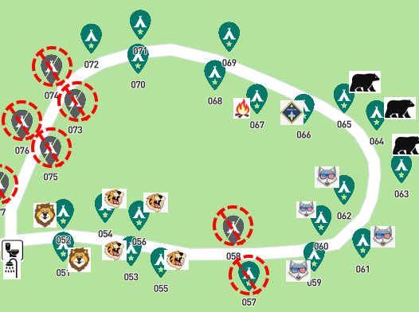

7. Hiking

There are various trails available and I’ve copied the trail map details below. To view the original see the following link - https://tpwd.texas.gov/publications/pwdpubs/media/park_maps/pwd_mp_p4504_0051h.pdf

